**Problem assignment 5**

*Due: Wednesday, October 9, 2019*

**Problem 1**

**Part a.**

|  |  |  |  |  |  |  |  |  |
| --- | --- | --- | --- | --- | --- | --- | --- | --- |
| **P** | **Q** | **S** | **T** | **U** | **KB** | | | **α** |
| **￢(P∧￢Q)∨￢(￢S∧￢T)** | **￢(T∨Q)** | **U→(￢T→(￢S∧P))** | **￢U** |
| TRUE | TRUE | TRUE | TRUE | TRUE | TRUE | FALSE | TRUE | FALSE |
| TRUE | TRUE | TRUE | TRUE | FALSE | TRUE | FALSE | TRUE | TRUE |
| TRUE | TRUE | TRUE | FALSE | TRUE | TRUE | FALSE | FALSE | FALSE |
| TRUE | TRUE | TRUE | FALSE | FALSE | TRUE | FALSE | TRUE | TRUE |
| TRUE | TRUE | FALSE | TRUE | TRUE | TRUE | FALSE | TRUE | FALSE |
| TRUE | TRUE | FALSE | TRUE | FALSE | TRUE | FALSE | TRUE | TRUE |
| TRUE | TRUE | FALSE | FALSE | TRUE | TRUE | FALSE | TRUE | FALSE |
| TRUE | TRUE | FALSE | FALSE | FALSE | TRUE | FALSE | TRUE | TRUE |
| TRUE | FALSE | TRUE | TRUE | TRUE | TRUE | FALSE | TRUE | FALSE |
| TRUE | FALSE | TRUE | TRUE | FALSE | TRUE | FALSE | TRUE | TRUE |
| TRUE | FALSE | TRUE | FALSE | TRUE | TRUE | TRUE | FALSE | FALSE |
| TRUE | FALSE | TRUE | FALSE | FALSE | TRUE | TRUE | TRUE | TRUE |
| TRUE | FALSE | FALSE | TRUE | TRUE | TRUE | FALSE | TRUE | FALSE |
| TRUE | FALSE | FALSE | TRUE | FALSE | TRUE | FALSE | TRUE | TRUE |
| TRUE | FALSE | FALSE | FALSE | TRUE | FALSE | TRUE | TRUE | FALSE |
| TRUE | FALSE | FALSE | FALSE | FALSE | FALSE | TRUE | TRUE | TRUE |
| FALSE | TRUE | TRUE | TRUE | TRUE | TRUE | FALSE | TRUE | FALSE |
| FALSE | TRUE | TRUE | TRUE | FALSE | TRUE | FALSE | TRUE | TRUE |
| FALSE | TRUE | TRUE | FALSE | TRUE | TRUE | FALSE | FALSE | FALSE |
| FALSE | TRUE | TRUE | FALSE | FALSE | TRUE | FALSE | TRUE | TRUE |
| FALSE | TRUE | FALSE | TRUE | TRUE | TRUE | FALSE | TRUE | FALSE |
| FALSE | TRUE | FALSE | TRUE | FALSE | TRUE | FALSE | TRUE | TRUE |
| FALSE | TRUE | FALSE | FALSE | TRUE | TRUE | FALSE | FALSE | FALSE |
| FALSE | TRUE | FALSE | FALSE | FALSE | TRUE | FALSE | TRUE | TRUE |
| FALSE | FALSE | TRUE | TRUE | TRUE | TRUE | FALSE | TRUE | FALSE |
| FALSE | FALSE | TRUE | TRUE | FALSE | TRUE | FALSE | TRUE | TRUE |
| FALSE | FALSE | TRUE | FALSE | TRUE | TRUE | TRUE | FALSE | FALSE |
| FALSE | FALSE | TRUE | FALSE | FALSE | TRUE | TRUE | TRUE | TRUE |
| FALSE | FALSE | FALSE | TRUE | TRUE | TRUE | FALSE | TRUE | FALSE |
| FALSE | FALSE | FALSE | TRUE | FALSE | TRUE | FALSE | TRUE | TRUE |
| FALSE | FALSE | FALSE | FALSE | TRUE | TRUE | TRUE | FALSE | FALSE |
| FALSE | FALSE | FALSE | FALSE | FALSE | TRUE | TRUE | TRUE | TRUE |

As showing in the table, whenever the KB is all true, the α=￢U is always true. So we can prove ￢U from KB.

**Part b.**

KB: ￢(P∧￢Q)∨￢(￢S∧￢T) ￢(T∨Q) U→(￢T→(￢S∧P)) Theorem: ￢U

First, use standard logical equivalences to rewrite each KB:

￢(P∧￢Q)∨￢(￢S∧￢T) <=> ￢P∨Q∨S∨T --- ① (use De Morgan)

￢(T∨Q) <=> ￢T∧￢Q --- ② (use De Morgan)

U→(￢T→(￢S∧P)) <=> ￢U∨T∨(￢S∧P)--- ③ (use Modus ponens)

Then, make the inference:

From ② and And-elimination, we get:

￢T --- ④

￢Q --- ⑤

From ①, ④, ⑤ and Unit-resolution, we get:

￢P∨S <=> ￢(￢S∧P) --- ⑥ (use De Morgan)

From ③, ⑤, ⑥, and Unit-resolution, we get:

￢U --- ⑦

And finally we proved the Theorem: ￢U.

**Part c.**

First, convert all the KB to CNF form:

￢(P∧￢Q)∨￢(￢S∧￢T) <=> ￢P∨Q∨S∨T

￢(T∨Q) <=> ￢T∧￢Q

U→(￢T→(￢S∧P)) <=> (￢U∨T∨￢S)∧(￢U∨T∨P)

Then, Negate the theorem to prove it via refutation

￢U --> U

Finally, run the resolution on the set of clauses:

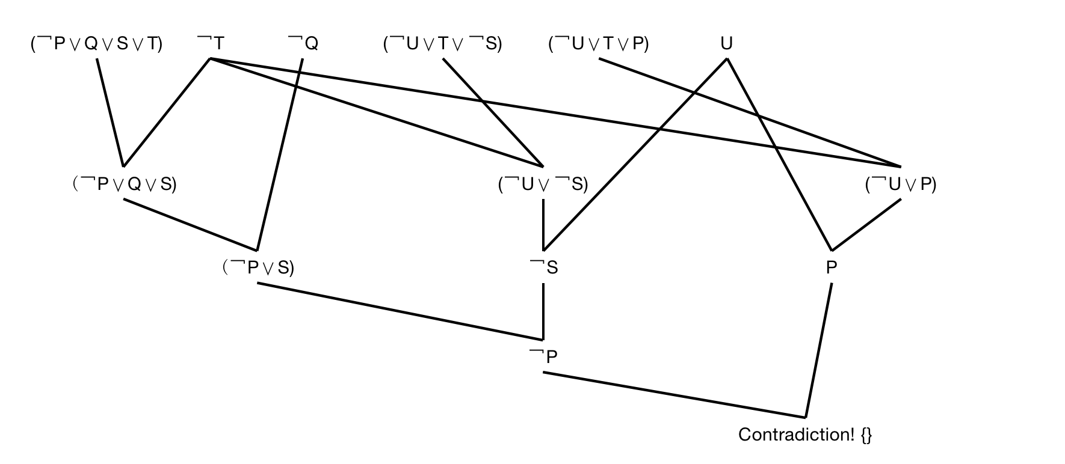

So we get contradiction at KB∧U. In that way, we proved ￢U.

**Problem 2.**

**Part a.**

Let’s first assign cases to each statement in the question:

A: the unicorn is mythical

B: the unicorn is immortal

C: the unicorn is a mortal mammal

D: the unicorn is horned

E: the unicorn is magical

According to the knowledge facts, we can get following propositional logic:

A→B ￢A→C (B∨C)→D D→E

**Part b.**

We can’t prove the unicorn is mythical.

**Part c.**

We can prove the unicorn is magical.

The KB are: A→B ￢A→C (B∨C)→D D→E

Theorem: E

First, use standard logical equivalences to rewrite each KB

A→B <=> ￢A∨B --- ①

￢A→C <=> A∨C --- ②

(B∨C)→D <=> ￢(B∨C)∨D --- ③

D→E <=> ￢D∨E --- ④

Then, make the inference:

From ① and ②, using Resolution, we get:

B∨C --- ⑤

From ③ and ⑤, using Unit Resolution, we get:

D --- ⑥

From ④ and ⑥, using Unit Resolution, we get:

E --- ⑦

Finally, we proved the Theorem: E. which means the unicorn is magical.

**Part d.**

We can prove the unicorn is horned.

The KB are: A→B ￢A→C (B∨C)→D D→E

Theorem: D

First, use standard logical equivalences to rewrite each KB

A→B <=> ￢A∨B --- ①

￢A→C <=> A∨C --- ②

(B∨C)→D <=> ￢(B∨C)∨D --- ③

D→E <=> ￢D∨E --- ④

Then, make the inference:

From ① and ②, using Resolution, we get:

B∨C --- ⑤

From ③ and ⑤, using Unit Resolution, we get:

D --- ⑥

Finally, we proved the Theorem: D. which means the unicorn is horned.

**Problem 3**

First, assign case to the initial facts, the FB:

A: the animal gives milk

B: it chews cud

C: it has long legs

D: it has long neck

E: it has tawny color

F: it has dark spots

**Theorem 1.**

Suppose that:

G: the animal is a mammal

H: the animal is an ungulate

And our theorem is:

I: the animal is a giraffe

From rule 2, we can get:

A→G using modus ponens, A→G, A => G

From rule 8, we can get:

(G∧B)→H using modus ponens, (G∧B)→H, G, B => H

From rule 12, we can get:

(H∧C∧D∧E∧F)→I using modus ponens, (H∧C∧D∧E∧F)→I, H,C,D,E,F => I

So we can prove theorem 1 is true. We use rule 2, 8 and 12 to derive the conclusion.

**Theorem 2.**

Suppose that:

J: the animal is a bird

K: the animal does not fly

L: the animal swims

M: it is black and white

And our theorem is:

N: the animal is penguin

From rule 15, we can get:

(J∧K∧L∧M)→N

However, for the part J∧K∧L∧M, we can not use any other rules listed above to prove their truth. So we can not prove the theorem 2 is true.

**Theorem 3.**

From rule 2, we can get:

A→G using modus ponens, A→G, A => G

So we can prove theorem 3 is true. We just use rule 2.

**Problem 4.**

**Part b.**

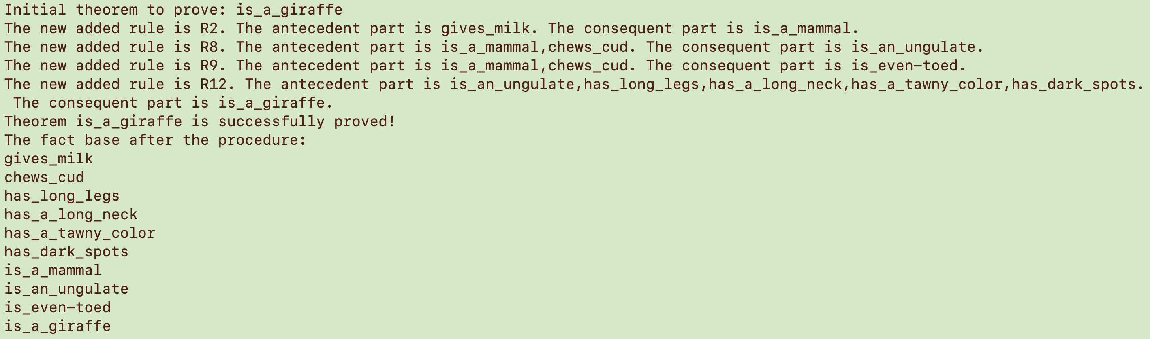

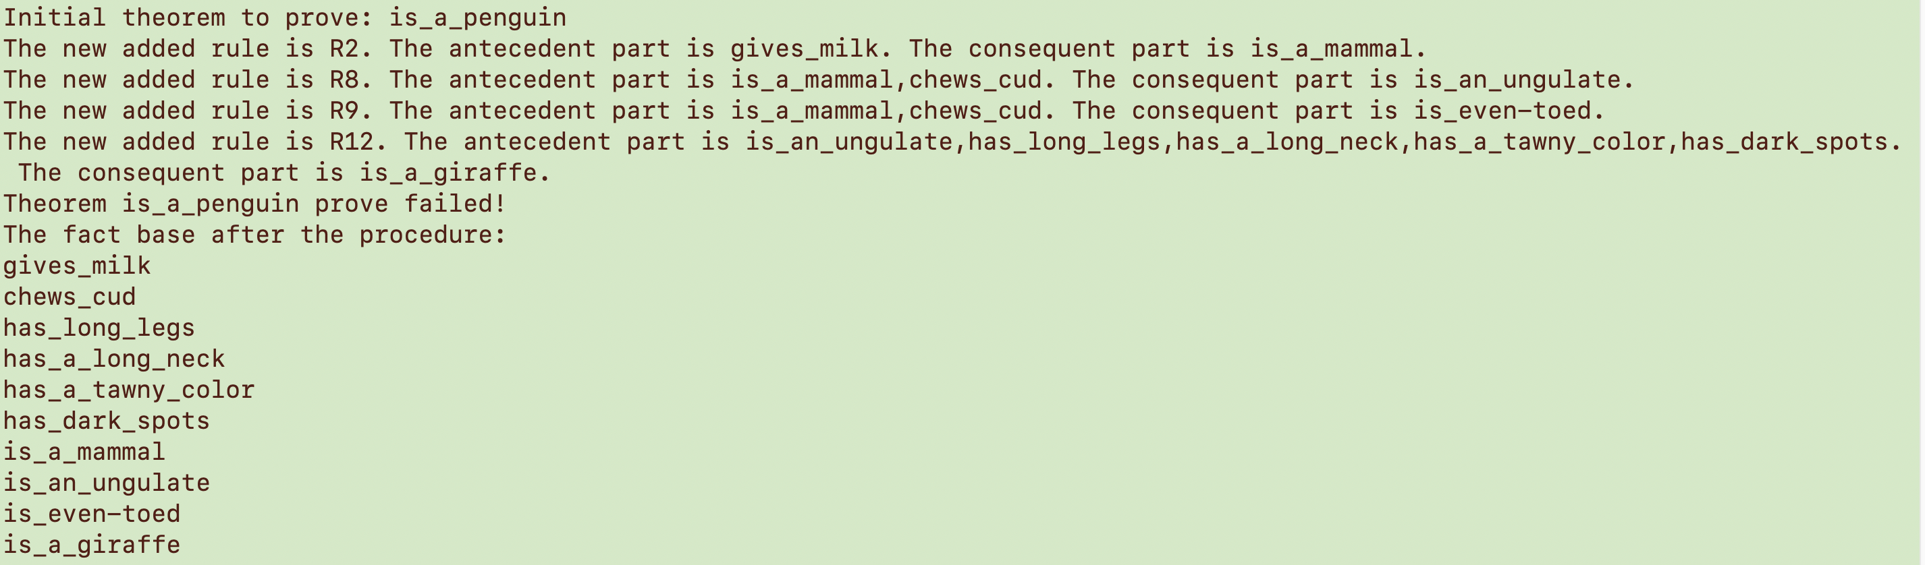

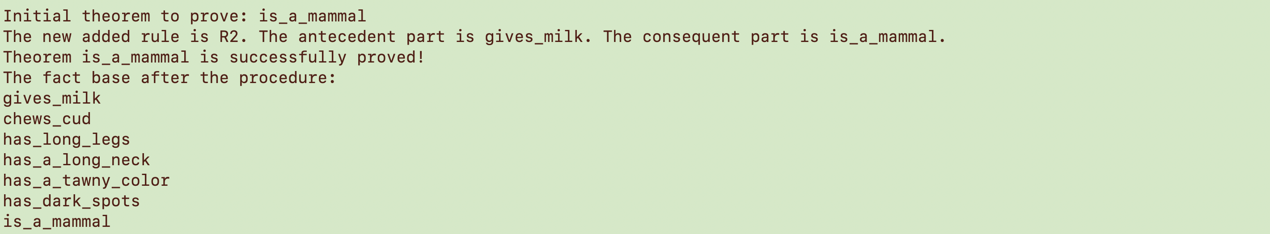

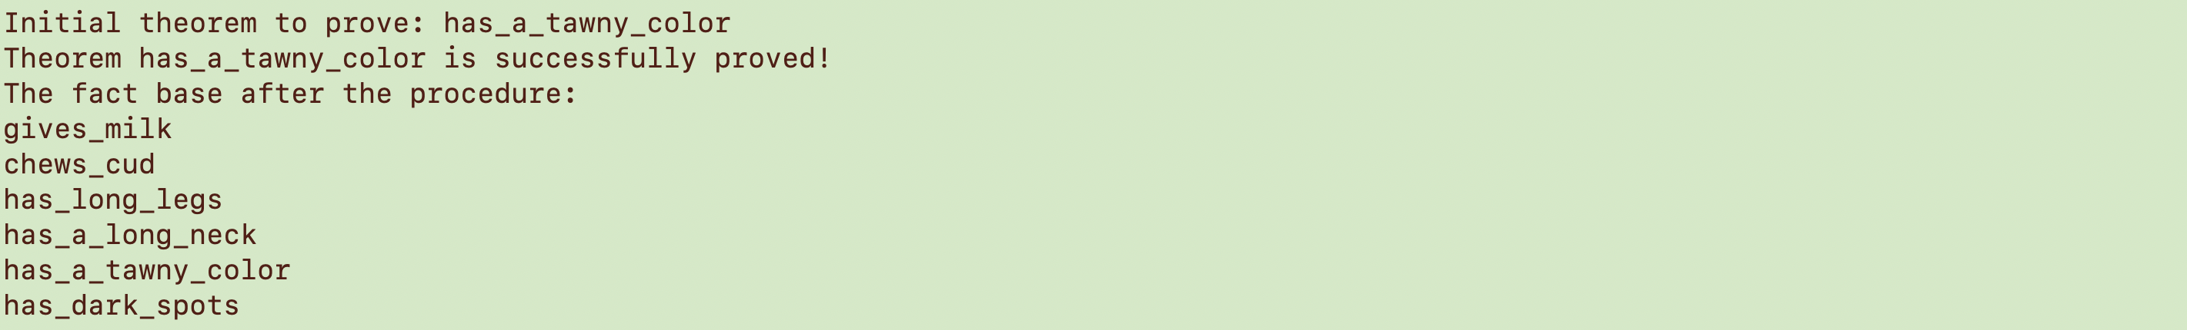

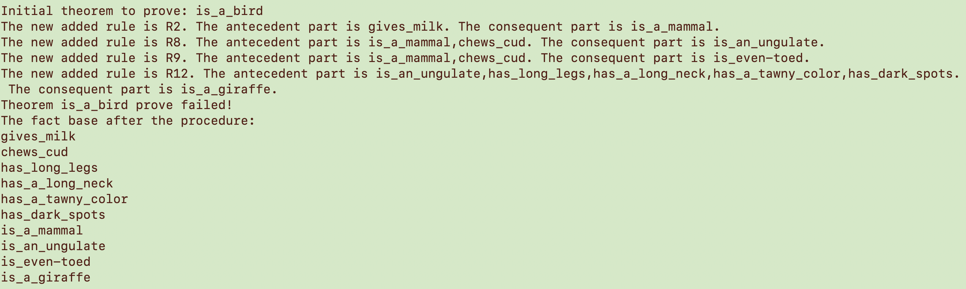

**Part c.**

 

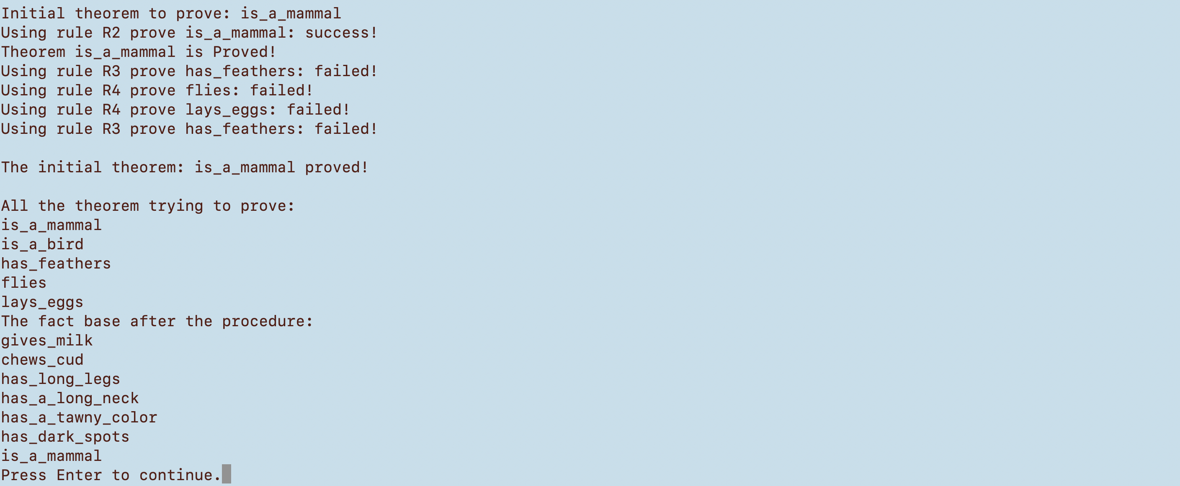 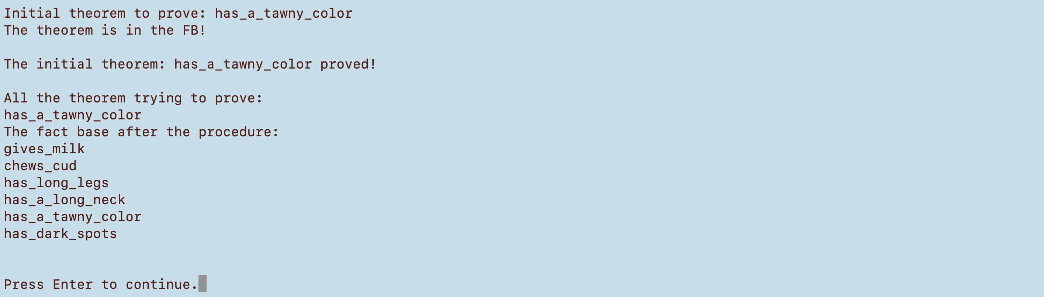

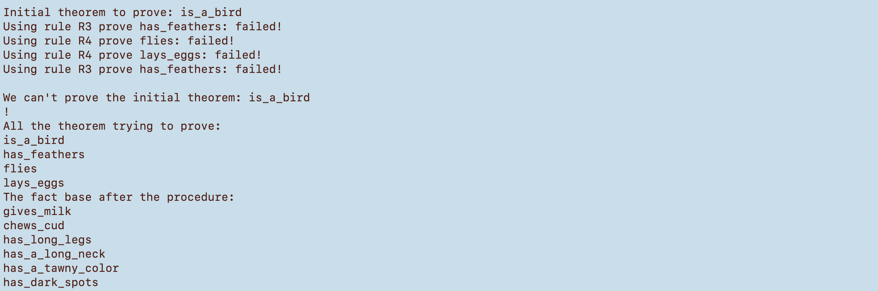

As shown above, part b is the result of forward chain and part c is backward chain. In terms of the fact base of both methods, if the initial theorem is proved, the fact base has no difference on two methods. However, if the initial theorem is not proved, like theorem2 and theorem4, the forward chain method would still add proved theorem into fact base, the backward chain won’t add.